# Steps to remove connection exceed

1. Open “Connection Exceed” menu which is under **Accounts.**

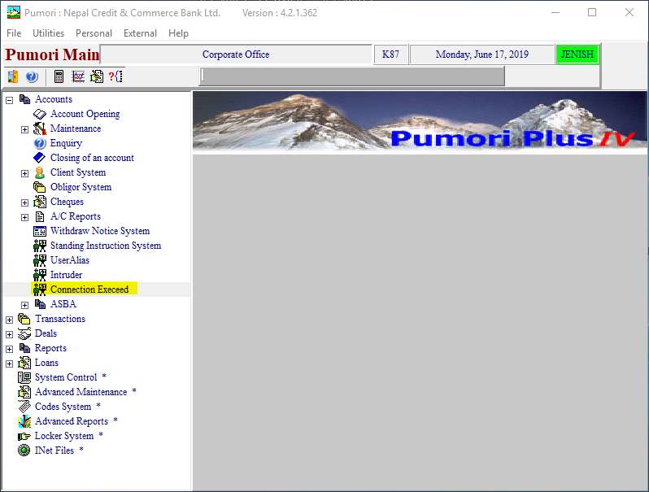

1. Click on “**List of Users**”

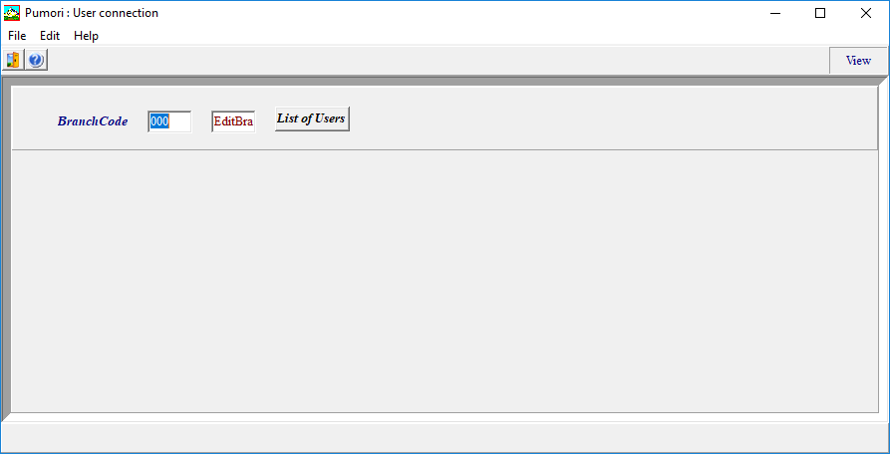

1. Double Click the UserId to remove the connection exceed.

